BlueBlast (07)
Robbie Atkin

Specification
BlueBlast will be a 2D game in which the player controls a blue robot named “Blast” who must make his way through a variety of stages that contain enemies, obstacles, and puzzles. To overcome enemies and complete each stage, the player must use Blast’s movement to solve puzzles and his laser arm as a defense against the enemies.
The story will consist of a robot called Blast, who was created with a desire and a passion for life, seizes the chance to flee the facility and embarks on a mission to elude the security robots. His ultimate objective is to settle down in the city and lead a peaceful life rather than serve as a pawn for someone else.
The mechanics of the game will consist of:
- Player Movement: The left and right arrow keys, as well as the A and D keys, can be used to navigate the player to the left and right of level. The up and down arrow keys, as well as W and S keys, can be used to navigate the player up or down the level.
- Player Health: The player starts off with three hearts, as they progress through the level they’re going to lose a couple of them, if they reach zero hearts then the player dies.
- Discs: These are the main focus of the game, the player must be able to pick up all of the discs within the level and attempt to get the smallest amount of time that they can.
- Wires: These are handy for the player to avoid due to the fact they only have three hearts, once all three are gone the player dies and must restart the level from the beginning.
- Timer: The timer which will be shown at the top of the level is the players score essentially, by achieving a low time, completing the game quicker, you are more likely to achieve a higher score.
There is only one level to BlueBlast but the point of the game is to play the same level but get the lowest amount of time it takes to complete it, the level is a garden where you must find six discs whilst avoiding any of the wires that might harm the player.

The target audience of the game will be children between the ages of 3 and 8, it should be the players first time picking up a game, they’re going to have little to understand whilst still maintaining a happiness and enjoyment whilst playing the game. It’s a very simple idea and will be able to set an initiative to the person playing. The game will also only be released for PC in its initial stage.

Art style of the game may consist of the game’s graphics being simplistic pixel art in a 2D manner. I want it to almost visually look like a very classic game to appeal to older generations on top of the young target audience as this game realistically can be for anyone.

In conclusion, the game will be a distinctive 2D game with fantastic features. BlueBlast will be simple and enjoyable, for young children and first time gamers.

Technical design
To start off with the player, it’s going to need to be in a struct to be able to hold data, such as health, sprite, direction, etc. of which we can create the player based off of that
struct Player
Sprite sprPlayer - Should contain the players sprite
Sprite sprDamage – Should contain the damage sprite which gets overlayed whenever the player is damaged
Bool moving – Quick and easy way to tell if the player is in the process of moving based off of a true or false response
Int discs – Integer to hold the players current disc amount in a number
Int health – Integer to hold the players amount of health in a number
Enum heading – Enum class which will have multiple options such as UP, DOWN, LEFT, RIGHT to be able to differentiate which direction the player is currently facing/moving in
The game is also going to require the able to switch between states, such as the Main Menu, Game, Ending, etc. These will then be used within it’s Update & Render functions to be able to differentiate between what logic/visual elements need to be done dependent on the game’s current state.

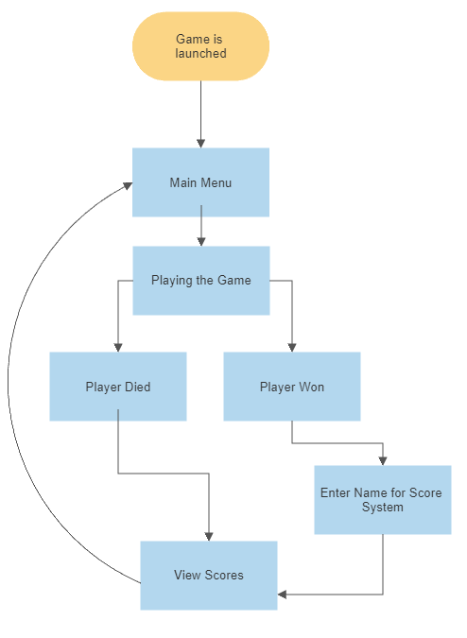
This flowchart here depicts the game state system, it starts off when the game is launched by instantly being assigned to the Main Menu, once the player chooses to begin the game it switches to the In-Game state. As the player progresses through the level they will either win or die and dependent on that the game state it will either switch to the Dead state or the Win state. If they progresses through the win state they will be met with the Enter Name state in which they have to enter their name to add to their score and then after that they will switch to the View Score state and they will be able to see the current score leaderboard. In the case the player dies they will instead of the Enter Name state they will go straight to the View Score state to see what they must beat. Once ready to move on from the View Score state they will loop back to the Main Menu and be able to continue the flow of the game from the beginning.

This is a technical language and technical diagram heavy explanation of HOW you are going to implement the specification. For a simple application, you want one or two appropriate diagrams or algorithms (flow chart, pseudocode, UML diagrams(level5), etc.). Overall your projects we should be able to see a couple of examples of all the technical design approaches/diagrams we’ve covered. If this was a big game project however, then this would span multiple pages with descriptions of code, diagrams, pseudocode, etc.

Test plan
How do you know when to stop, how do you know it works, is it working appropriately (fun), etc. Again, for a small application, this would probably be the classic basic table of test input and what you expect it to output. For larger programs this could include instructions on different tasks the user is meant to perform, and how they are meant to work – imagine you were writing instructions for a test department with staff who don’t know you or the code. For a big game project it would include instructions on what the player is expected to feel, is this bit meant to be easy, are they supposed to be confused, is this bit meant to be hard, how long is it meant to take to play this bit, etc. Then you play test and observe. For big projects you’d use an issue tracker (bitbucket) to record information about all these things and figure out which are important and need fixing and which aren’t (it’s not complex, just a shared online repository of bugs with priorities). It’s part of the classic software development lifecycle, design->implement->test->repeat until you get something really good. Fail fast, fail early. Find the optimum solution. For a large project you’d include user testing, where you watch someone play and make notes about what they liked, didn’t like, where they got stuck, if something broke, balance issues – things too easy or hard, things too confusing, etc.

GiT commit log
All work should be kept on GiT, bitbucket and github are free to use. Make sure the repository is marked private or people will google the code and find it. A screen shot of the git commit log will suffice, it needs to show who did what and when. At level 4 it will take a while to learn to use GiT, but we will eventually.

Schedule
Apply some common sense, if it’s a simple application, if it’s small, then a basic bullet point list is fine. E.g. simple assessment, Joe wants to get it finished for the week after next session. Sets aside 4hrs: 0.25hr spec, 0.5hr design, 3hr implement, 0.25min test, 1hr slack. See how long it really takes, next time adjust accordingly.
Task | Estimated Hrs | Actual Hrs
Spec | 0.25 | 0.25
Design | 0.5 | 0.25
Implement | 3 | 2.5
Debug and test | 0.25 | 3.5
Slack | 1 | 0
total | 5 | 6.5

If it’s a big project that’s going to be more like 10+ hours, then you need Trello. Schedules can be done in Trello and screen shots used, refer to the notes on Trello, you need to use the ‘Plus’ plugin for Chrome so you can estimate how long things will take, this is how you guesstimate when the project will be finished – this is absolutely critically important to the people paying your wages. Think of all the tasks and put them on ‘cards’, shuffle them around, keep breaking them down into smaller tasks on more cards, until you’ve written 1 or 2 hours on each card. Trello will tell you how long the whole thing will take. As you work, mark off the tasks as done and how much time they REALLY took. It takes effort, but is the only way to get better at task estimation. It’s important because YOU are the biggest cost to your employer.

